Full Stack Development with MERN Project Documentation format

1. Introduction
- Project Title: SHOPEZ – MERN-Based E-Commerce Application
- Team Members:
Name | Role
Veera Durga Dineshini Yarram | Team Lead, Frontend Development & Project Coordination
Rabbani Mahammad | Backend Development (Node.js & Express.js)
Lokesh Manthina | Database Management (MongoDB & Mongoose)
Kamatham Navya | Frontend Development (React.js UI & Components)
Uday Kumar Chilamkurthi | Testing, Documentation & Deployment

2. Project Overview
- Purpose:
The purpose of SHOPEZ is to provide a secure, responsive, and user-friendly online shopping platform where customers can browse products, add items to their shopping cart, place orders, and track purchases. The application also provides an admin panel for managing products, users, and orders efficiently.
- Features:
- • User Registration and Login
- • JWT Authentication
- • Product Management
- • Product Search
- • Shopping Cart
- • Order Placement
- • Order History
- • Admin Dashboard
- • Responsive User Interface

3. Architecture
- Frontend:
- Built with React.js: Component-based architecture for reusability
- Single Page Application (SPA): Smooth navigation without page reloads
- Responsive Design: Optimized for desktop and mobile devices
- State Management: React Context API for global state (Authentication, Cart)
- Routing: React Router for page navigation
- HTTP Client: Axios for API communication
- Multiple Pages: Login, Register, Products, Cart, Checkout, Orders, Profile
- Reusable Components: Navbar, Product Cards, Cart Items, Order Cards

- Backend:
Built with Node.js & Express.js: Fast and scalable server-side framework
- RESTful API: Clean API endpoints for all functionalities
- MVC Architecture: Separation of concerns (Models, Controllers, Routes)
- Modular Structure: Separate controllers and routes for each feature
- Middleware: JWT Authentication, Admin Authorization, Error Handling, CORS
- Environment Variables: Secure configuration using dotenv

- Database:
- Built with MongoDB: NoSQL database for flexible data storage
- Mongoose ODM: Schema-based data modeling with validation
- Collections:
  - Users: User info, authentication, roles (isAdmin)
  - Products: Product catalog, categories, stock, images
  - Carts: User cart items, quantities, totalAmount
  - Orders: Order history, shipping address, payment, status
- Relationships: User → Cart (One-to-One), User → Orders (One-to-Many)
- Data Validation: Mongoose schema validations for data integrity

4. Setup Instructions
- Prerequisites:
- • Node.js
- • MongoDB
- • Git
- • VS Code
- Installation:

5. Folder Structure
- Client:
client/
│
├── public/
├── src/
│ ├── components/
│ ├── pages/
│ ├── context/
│ ├── services/
│ ├── App.js
│ └── index.js
- Server:
server/
│
├── config/
├── controllers/
├── middleware/
├── models/
├── routes/
├── uploads/
├── server.js

6. Running the Application
• Provide commands to start the frontend and backend servers locally.
- Frontend:
_{cd client}
_{npm start}
- Backend:
cd server
npm start

7. API Documentation
Method | Endpoint | Description
POST | /api/users/register | Register User
POST | /api/users/login | Login User
GET | /api/products | View Products
GET | /api/products/:id | Product Details
POST | /api/cart | Add to Cart
POST | /api/orders | Place Order

8. Authentication

Authentication is implemented using JSON Web Token (JWT). Users must log in with valid credentials to receive a token, which is used to access protected routes. Passwords are securely hashed before storage, ensuring safe authentication and authorization.
- User Interface
Login Page:
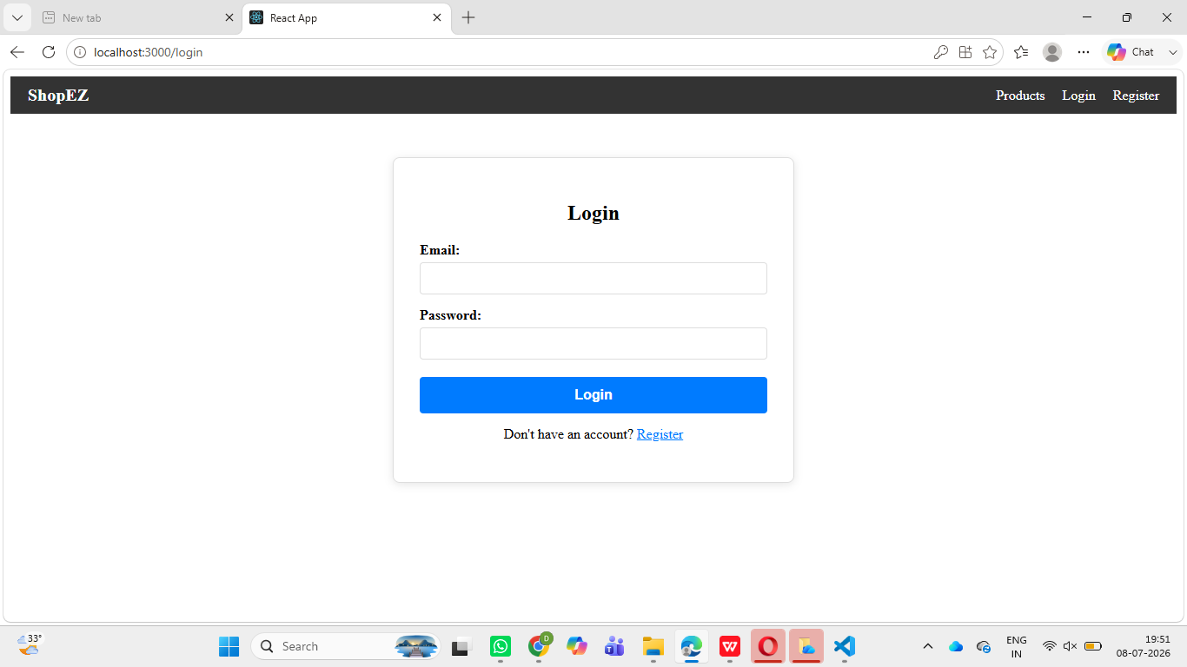
Product page:
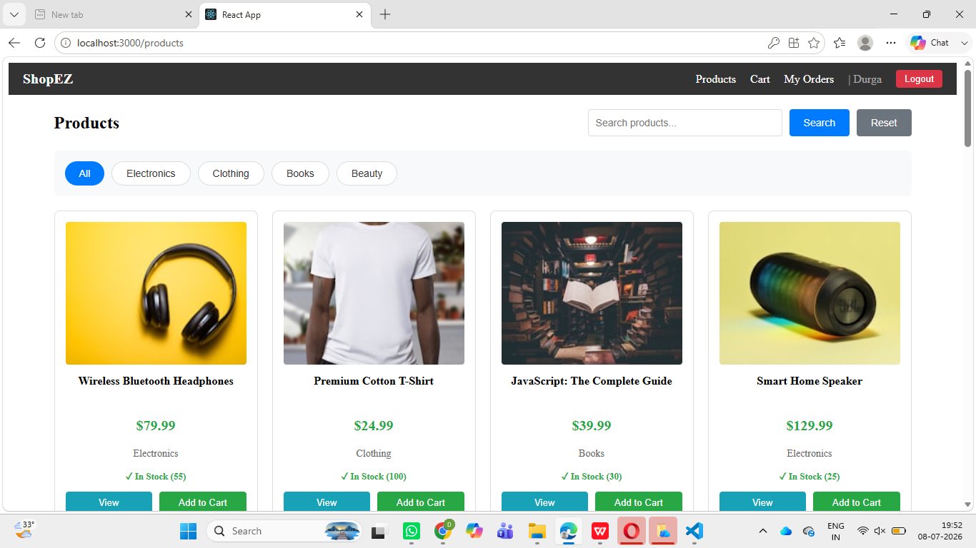
Shopping cart:
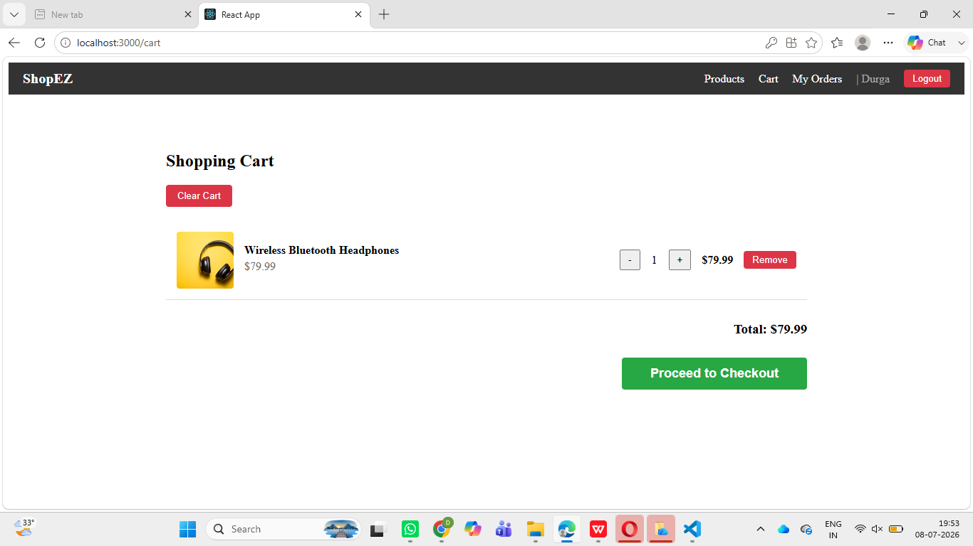
Checkout page:
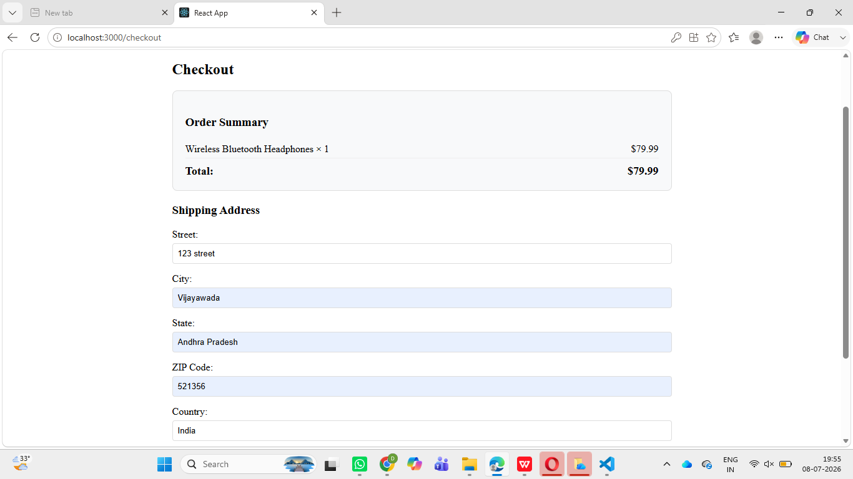
Orders page:
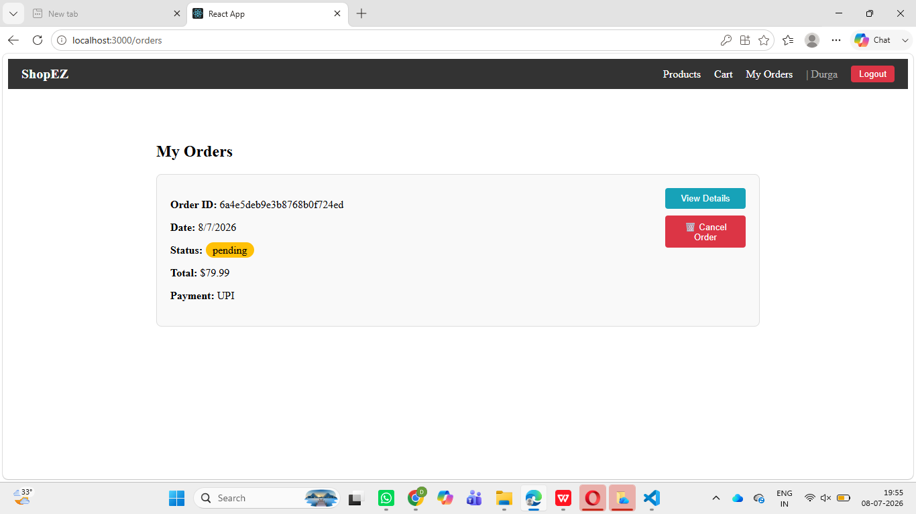
- Testing
- User Registration Testing
- Login Testing
- Product CRUD Testing
- Shopping Cart Testing
- Order Placement Testing
- API Endpoint Testing

- Screenshots or Demo
  - Demo Video:
SHOPEZ_Project_Demo.mp4
- Known Issues
• Payment gateway is not integrated (if applicable).
• Internet connection is required.
• Performance may decrease with a large number of simultaneous users.

13.Future Enhancements
• Online Payment Gateway Integration
• AI-Based Product Recommendations
• Wishlist Feature
• Product Reviews and Ratings
• Push Notifications
• Mobile Application
• Multi-language Support

